CARBON FIBER WEAVES
Generally categorized under the headings Plain, Twill and Harness Satin.
TOWS To begin creating fabrics, manufacturers create bundles of carbon fibers called tows. Tows are rated according to their fiber, or filament, content and commonly referred to as 3k, 6k, 12k, and 15k. The k stands for “thousand,” meaning a 3k tow is composed of 3,000 carbon filaments. Since a single strand of carbon fiber is only about 5-10 microns thick, a 3k tow comes in at only around .125” thick! A 6k tow would then be about twice as thick as the3k tow, and a 12k tow is four times as thick.
The high number of strong carbon fibers in such a compact space is what gives carbon fiber materials their incredible strength, especially when considering how little their mass weighs.
Carbon fiber tows are woven into fabrics on a weaving loom. The most common weaves created are plain, twill, and harness satin.

PAIN WEAVE
The plain weave, (or 1x1 weave) carbon fiber fabric is symmetrical and resembles a checkerboard.
The tows are woven in a simple over/under pattern, resulting in tightly interlaced fibers which are highly stable. (Fabric stability refers to a material’s ability to maintain its fiber orientation and weave angle.) The plain weave structure has high fabric stability, which means it is not very flexible. This makes the plain weave unsuitable for forming over complex contours. However, it is easier to handle without creating distortions in the fabric. The plain weave works well for flat sheets, tubes, and two-dimensional curves.
Crimp is the curvature of a single fiber in a weave, and plain weave carbon fiber fabric has a harsh crimp due to the tight interlaces in the tows. This harsh crimp can create stress points that cause areas of weakness over time.

TWILL WEAVE
Twill weave consists of a 2x2 or 4x4 pattern and is the most recognized type of carbon fiber fabric.

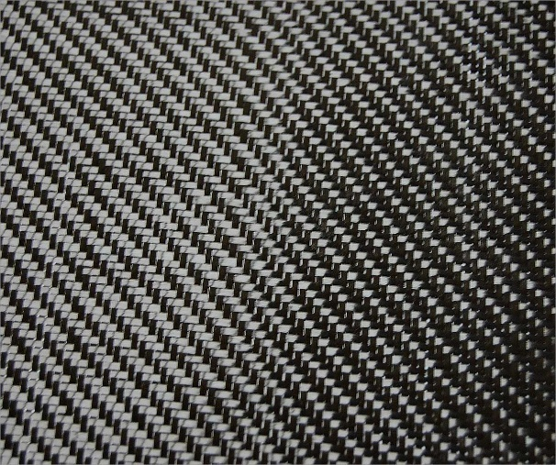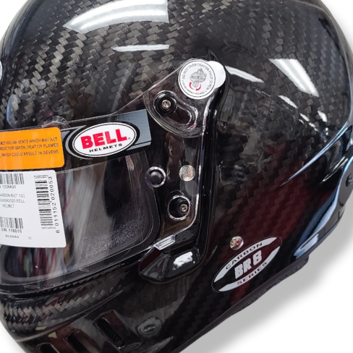

In a 2x2 weave, each tow passes over two tows and then under two tows. A 4x4 weave consists of each tow passing over four tows and then under four tows. This over/under weaving creates a distinct diagonal pattern The distance between the tow interlaces in a twill weave is longer than with a plain weave. Therefore, fewer crimps occur, allowing less opportunity for stress points to be created.

Twill weave is pliable and can form to complex contours while still maintaining good stability. It must be handled more carefully than a plain weave fabric to avoid adding distortions to the weave. A 4x4 weave is easier to form than a 2x2 weave, but it also has less fabric stability.

HARNESS SATIN WEAVE
Satin weaves have been used for thousands of years to give silk fabric its beautiful draping quality while leaving the fabric smooth and seamless. When used with carbon fiber composites, satin weaves translate to an ability to easily form around complex contours. However, this also means satin weaves offer less stability than other weaves.
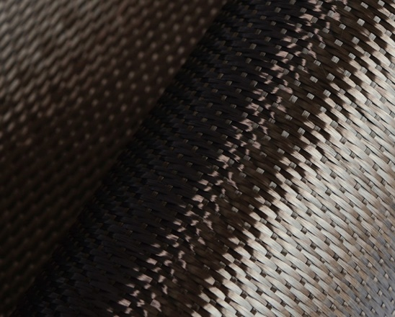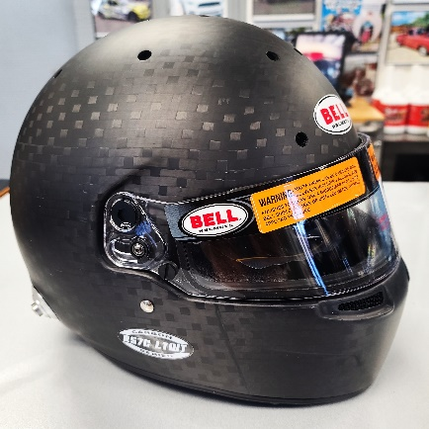
The most common harness satin weaves are four harness satin (4HS), five harness satin (5HS), and eight harness satin (8HS). The number indicates the total number of tows passed over then under. For example, a 4HS weave consists of three tows passed over and then one passed under. For 5HS, four tows are passed over, and then one under, and 8HS is seven tows passed over and one under. The higher the satin weave number, the more formable and less stable it is.

OTHER WEAVES
There are a few other weaves that can be used to create carbon fiber These include fish weave, spread tow, braids, unidirectional weave and custom weaves. Each weave supports unique properties that make it great for use in some designs and not a good choice for others. When determining which weave to use fabricators must first consider the fabrics strength, formability, stability, and crimp.
Carbon fiber fabricators are experts in knowing which fabric to use for which design.
https://dragonplate.com/carbon-fiber-101-understanding-weaves-and-fabrics
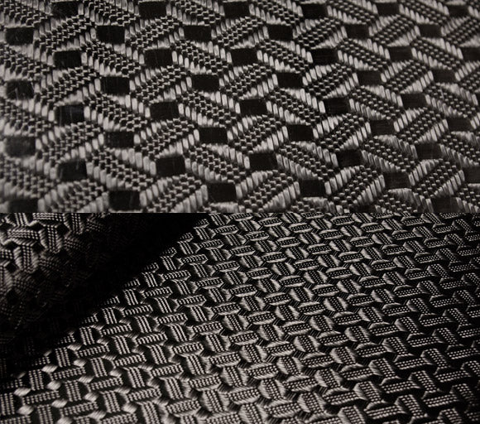
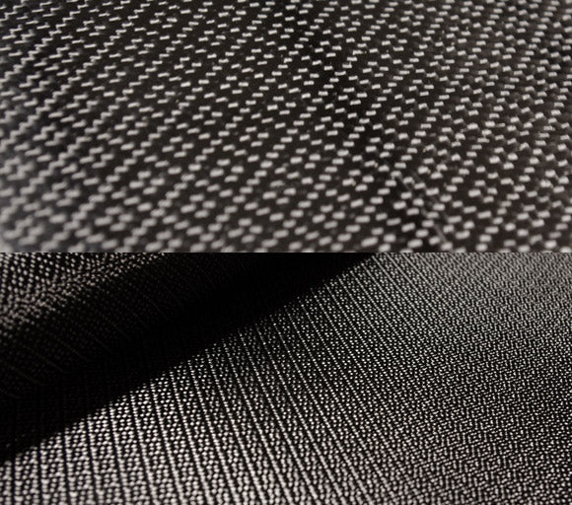ATOMIC 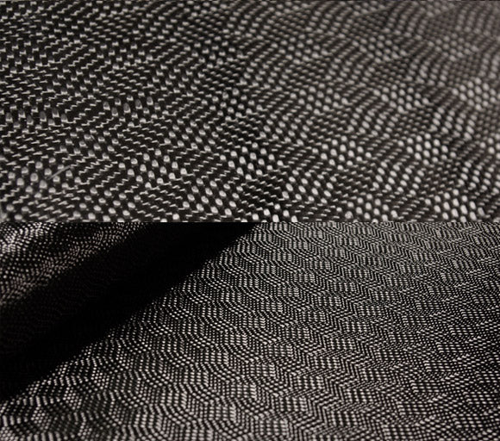 LABYRINTH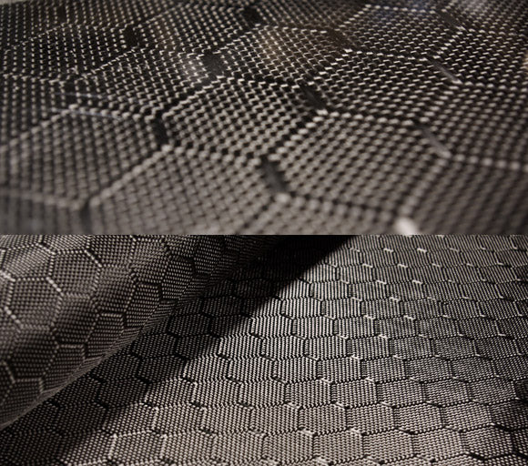WASP ROSEWELL

(Images carbonfibergear.com)

